**Project Design Phase-I** **Solution Architecture**

|  |  |
| --- | --- |
| Date | 30 October 2023 |
| Team ID | NM2023TMID06777 |
| Project Name | Blockchain – FOOD TRACKING SYSTEM |
| Maximum Marks | 4 Marks |

# Solution Architecture:

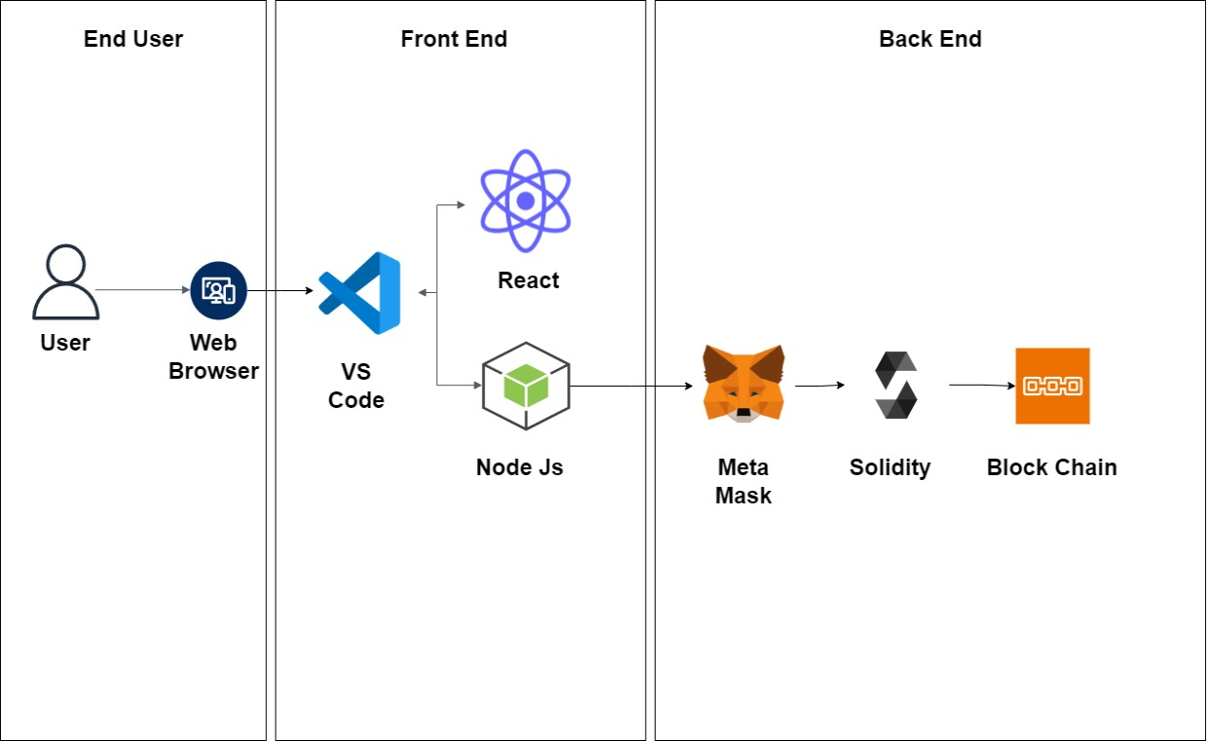

**Solution architecture Description:**

# End User:

* This is where users interact with the blockchain application. It can be a web app.
* The voting site can be accessed via the browsers from all the devices by every user

# Front End:

* React js - allows to create an interactive webpage which displays content for the end- user through the web browser through this the data representation is done
* Node js - A JavaScript library that enables the frontend to interact with the blockchain. It communicates with the blockchain node and communicates the data from user to blockchain and viceversa.

# Back End:

* Meta mask - simplifies the process of user authentication and transaction signing for blockchain-based applications. It allows users to securely interact with the Ethereum blockchain and DApps while keeping their private keys safe.
* Solidity(Remix ide) - Solidity is a high-level, statically-typed programming language used for developing smart contracts on various blockchain platforms, with Ethereum being the most prominent. Smart contracts are self-executing contracts with the terms of the agreement directly written into code.
* Remix IDE - is an essential tool for Solidity developers and is widely used in the Ethereum ecosystem. It simplifies the smart contract development process and provides many useful features for coding, testing, and deploying contracts on the Ethereum blockchain.
* Block Chain - Blockchain is a distributed and decentralized digital ledger technology that is used to record transactions across multiple computers in a way that ensures the security, transparency, and immutability of the data.